**Practical-13**

**AIM: Set up a Continuous Integration/Continuous Deployment Pipeline.**

In this Practical, you will learn how to create an automated software release pipeline that deploys a live sample app. You will create the pipeline using AWS CodePipeline, a service that builds, tests, and deploys your code every time there is a code change. You will use your GitHub account, an Amazon Simple Storage Service (S3) bucket, or an AWS CodeCommit repository as the source location for the sample app’s code. You will also use AWS Elastic Beanstalk, an Amazon Simple Storage Service (S3) bucket as the deployment target for the sample app. Your completed pipeline will be able to detect changes made to the source repository containing the sample app and then automatically update your live sample app.

Continuous deployment allows you to deploy revisions to a production environment automatically without explicit approval from a developer, making the entire software release process automated.

Implement the attached scenario & perform the following tasks:

• Host Static Website in S3 Bucket.

• Push data from local repository to remote repository.

• Create AWS CodePipeline.

• How to use Pipeline and Auto-update the website Hosted in S3 Bucket from GitHub?

Log into AWS Management Console with your credentials

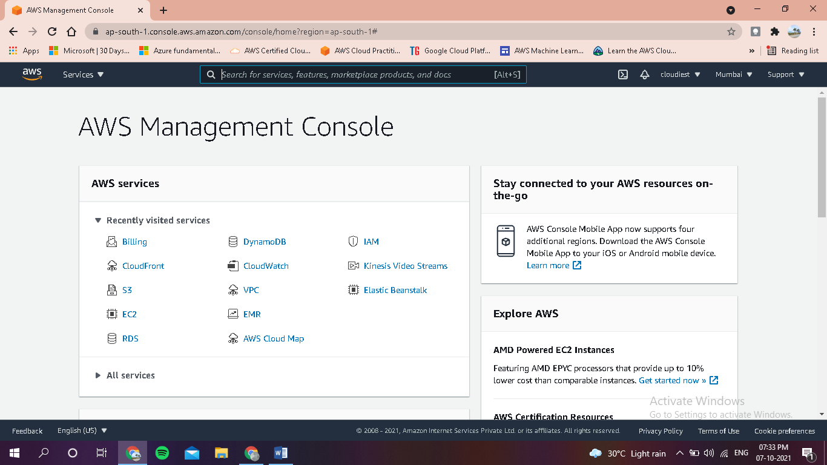

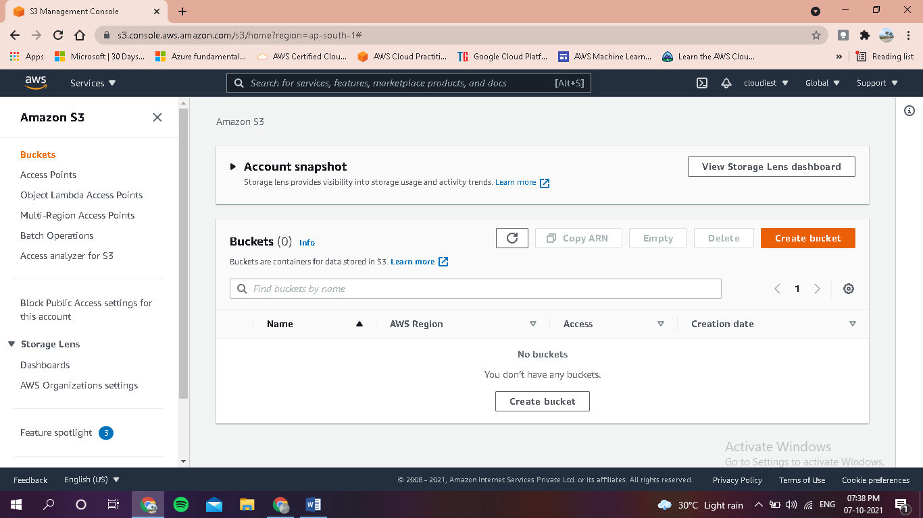

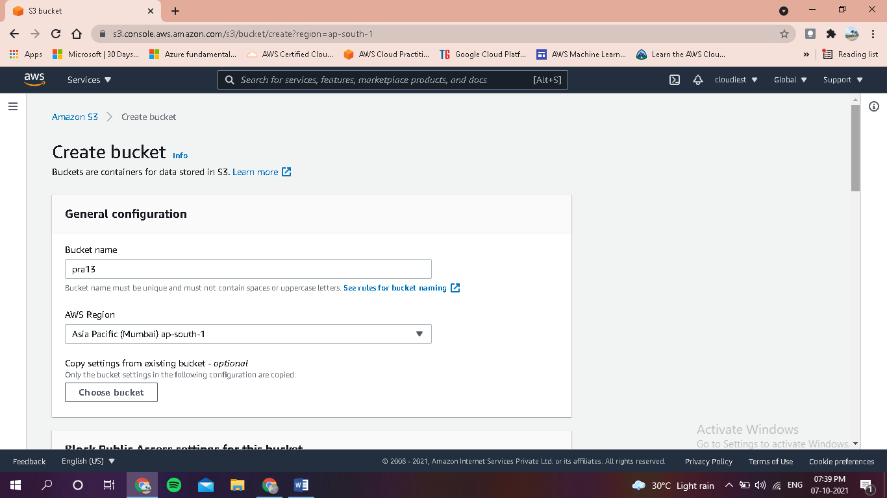

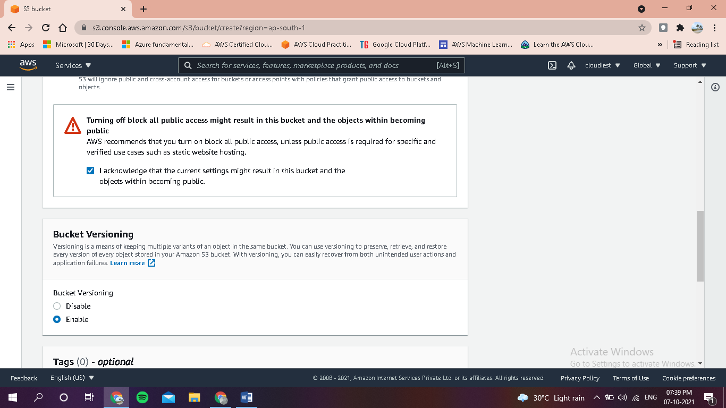

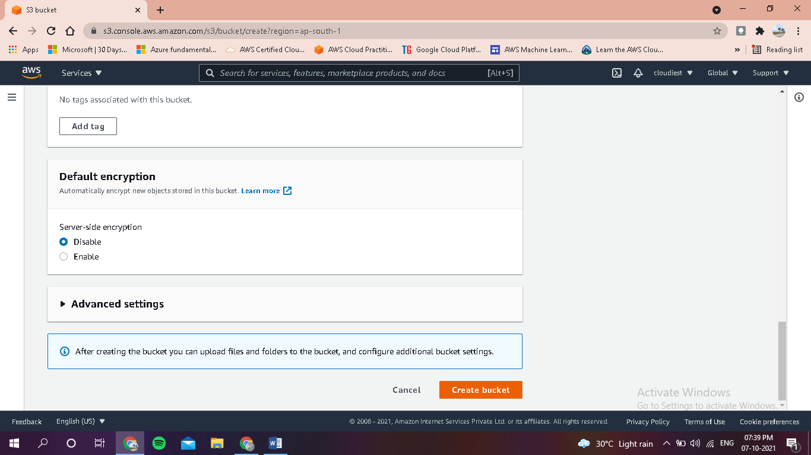

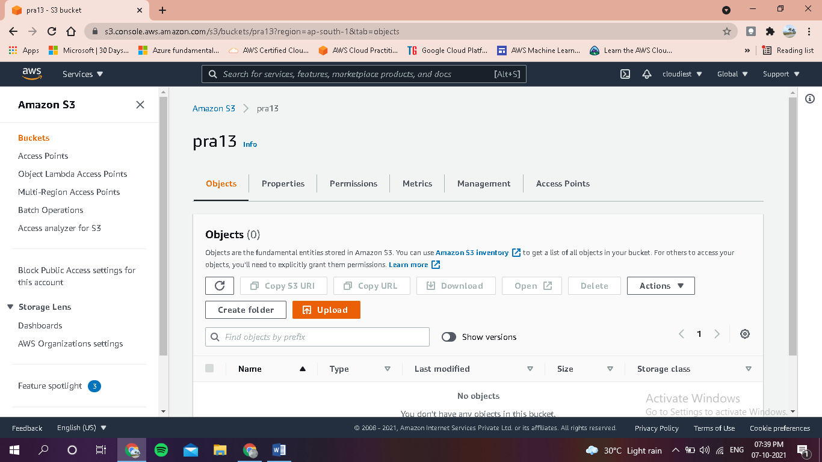

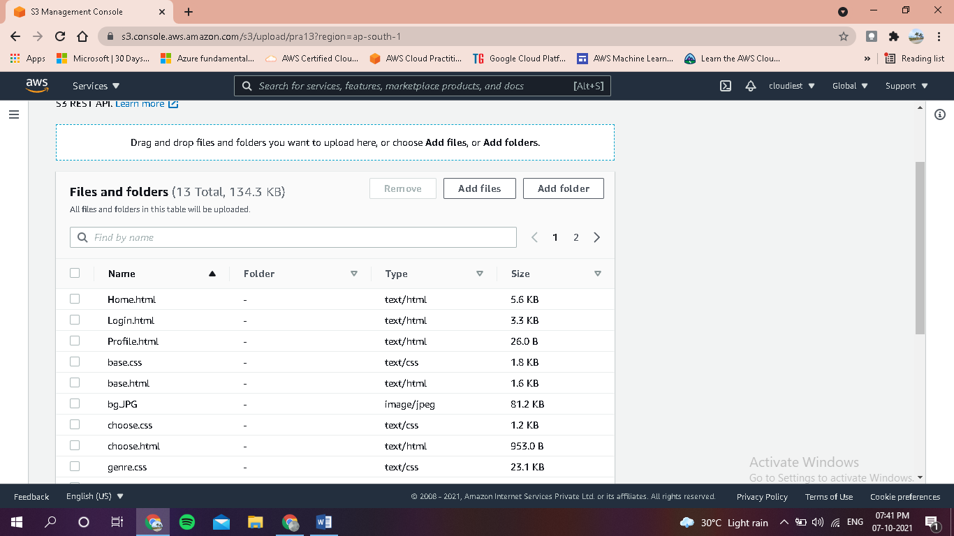

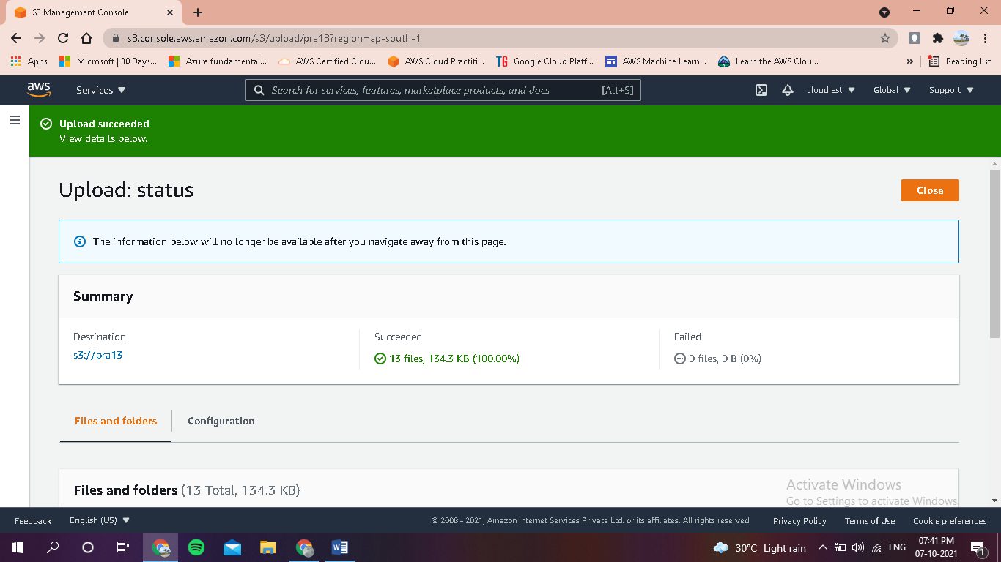

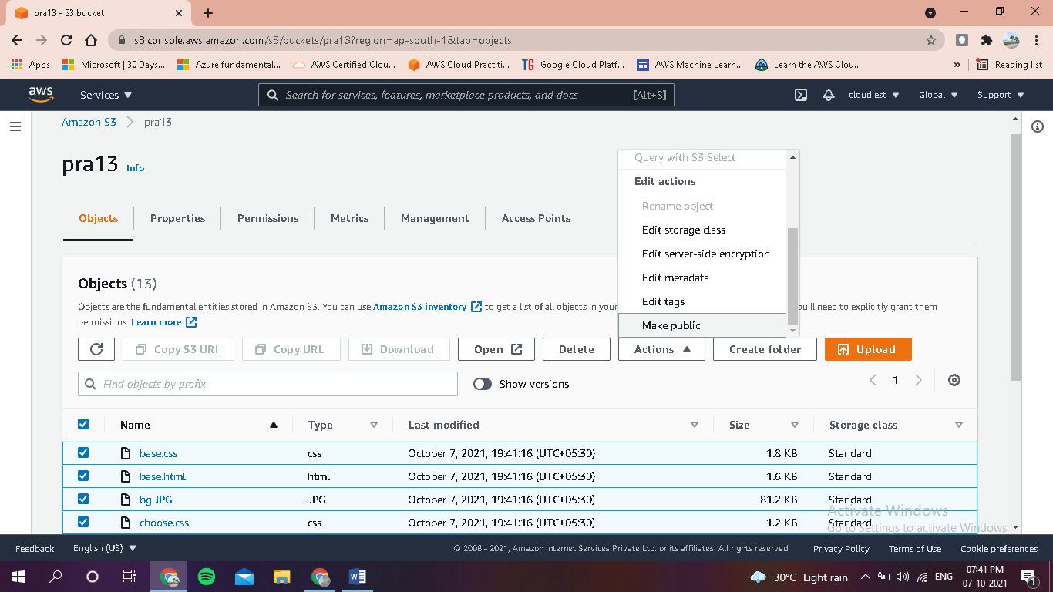

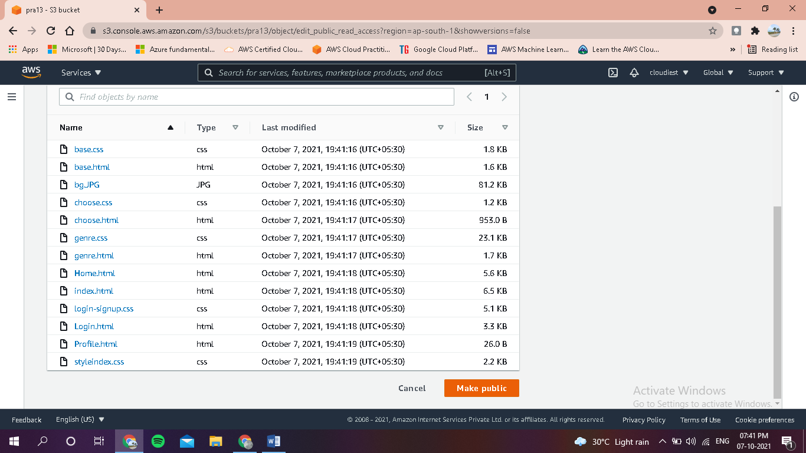

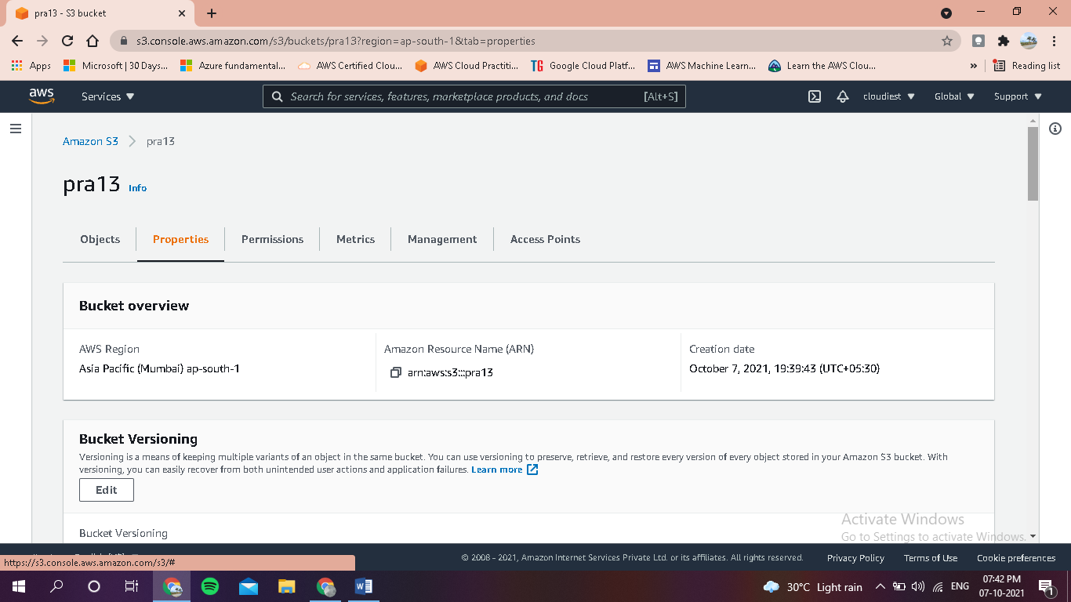

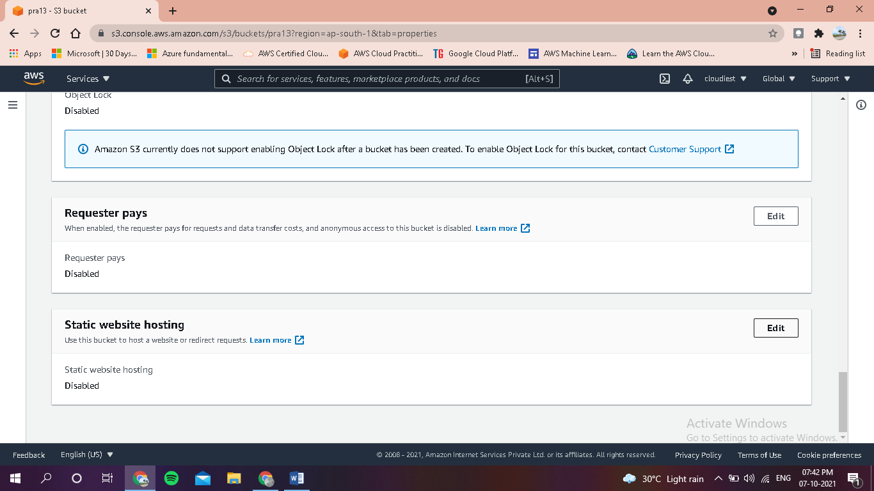

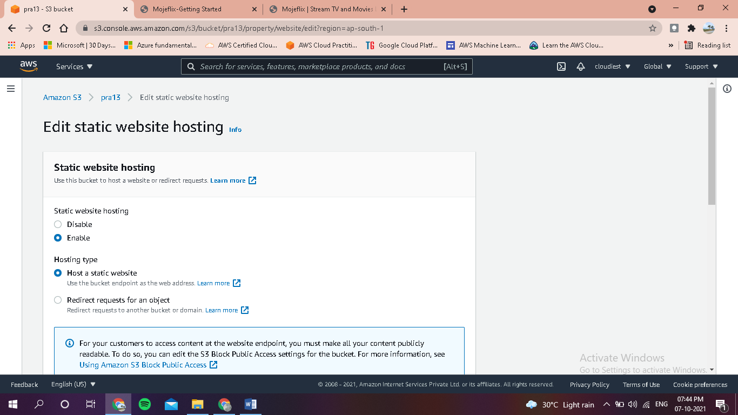

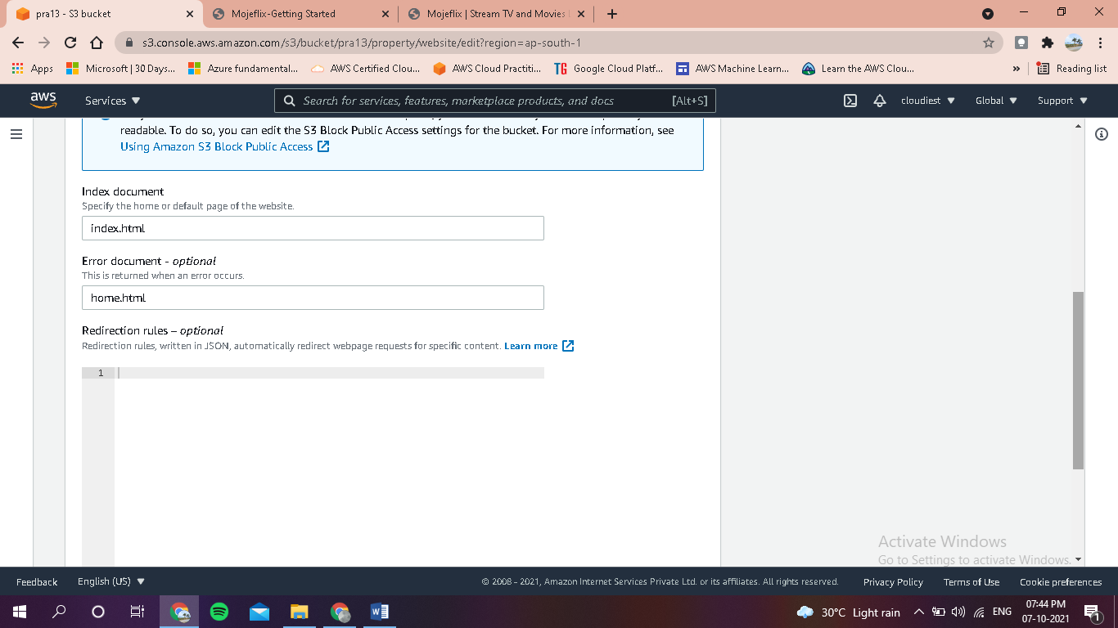

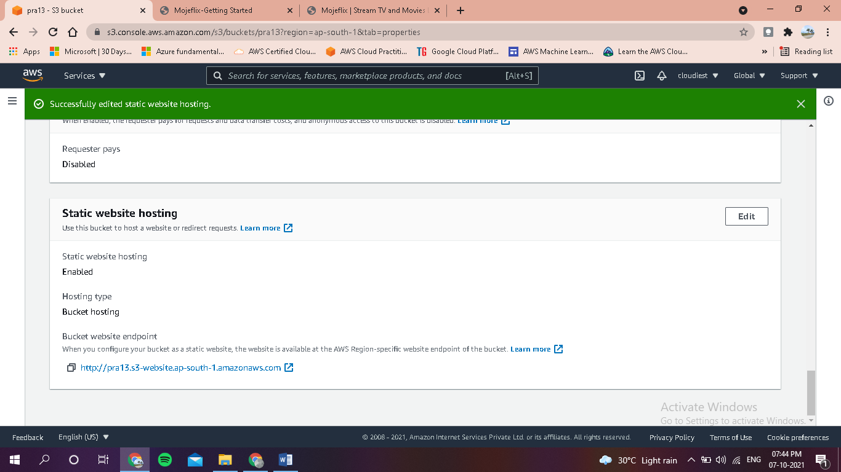

http://pra13.s3-website.ap-south-1.amazonaws.com



